**ASSINGMENT-3**

|  |  |
| --- | --- |
| Assignment Date | 19 September 2022 |
| Student Name | SARITHA.C |
| Student Roll Number | 715319106015 |
| Maximum Marks | 2 Marks |

**AI based discourse for Banking Industry**

**Introduction**

Artificial intelligence has become a critical disruptor in almost every industry, including banking and finance. The introduction of  [all in banking apps](https://appinventiv.com/blog/artificial-intelligence-revamping-user-experience-in-mobile-banking-apps/) and services has made the sector more customer-centric and technologically relevant.

AI-based systems can help banks reduce costs by increasing productivity and making decisions based on information unfathomable to a human agent. Also, intelligent algorithms are able to spot fraudulent information in a matter of seconds.

A [report by Business Insider](https://www.businessinsider.in/finance/news/the-impact-of-artificial-intelligence-in-the-banking-sector-how-ai-is-being-used-in-2020/articleshow/72860899.cms) suggests that nearly 80% of banks are aware of the potential benefits that AI presents to their sector. Another report suggests that by 2023, banks are projected to [save $447 billion](https://www.businessinsider.com/ai-in-banking-report) by using AI apps. These numbers indicate that the banking and finance sector is swiftly moving towards AI to improve efficiency, service, productivity, and reduce costs.

In this article, we will find out the key applications of AI in banking/finance sector and how this technology is redefining customer experience with its exceptional benefits.

### ****Tracking market trends****

Artificial intelligence in financial services helps banks to process large volumes of data and predict the latest market trends, currencies, and stocks. Advanced machine learning techniques help evaluate market sentiments and suggest investment options.

AI for banking also suggests the best time to [invest in stocks](https://appinventiv.com/blog/stock-trading-app-development/) and warns when there is a potential risk. Due to its high data processing capacity, this emerging technology also helps speed up decision-making and makes trading convenient for both banks and their clients.

### ****Data collection and analysis****

Banking and finance institutions record millions of transactions every single day. Since the volume of information generated is enormous, its collection and registration turn into an overwhelming task for employees. Structuring and recording such a huge amount of data without any error becomes impossible.

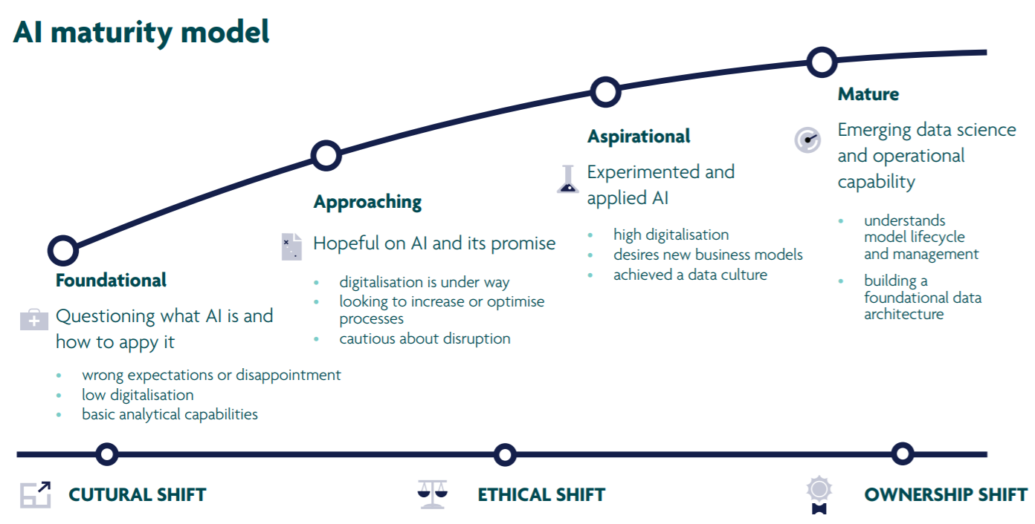

**Basic Python**

**1. Split this string**

In [1]:

s **=** "Hi there Sam!"

In [2]:

s**.**split();

Out[2]:

['Hi', 'there', 'Sam!']

**2. Use .format() to print the following string.**

**Output should be: The diameter of Earth is 12742 kilometers.**

In [3]:

planet **=** "Earth"

diameter **=** 12742

In [4]:

print('The diameter of {} is {} kilometers.' **.**format(planet,diameter));

The diameter of Earth is 12742 kilometers.

**3. In this nest dictionary grab the word "hello"**

In [5]:

d **=** {'k1':[1,2,3,{'tricky':['oh','man','inception',{'target':[1,2,3,'hello']}]}]}

In [6]:

print(d['k1'][3]["tricky"][3]['target'][3])

hello

**Numpy**

In [ ]:

**import** numpy **as** np

**4.1 Create an array of 10 zeros?**

**4.2 Create an array of 10 fives?**

In [7]:

**import** numpy **as** np

array**=**np**.**zeros(10)

print("An array of 10 zeros:")

print(array)

An array of 10 zeros:

**6. Create a 3x3 matrix with values ranging from 0 to 8**

In [10]:

**import** numpy **as** np

x **=** np**.**arange(0, 9)**.**reshape(3,3)

print(x)

[[0 1 2]

[3 4 5]

[6 7 8]]

**7. Concatenate a and b**

**a= np.array([1, 2, 3]), b = np.array([4, 5, 6])**

In [11]:

a**=**np**.**array([1,2,3])

print(a)

b**=**np**.**array([4,5,6])

print(b)

print('\n----Result of a and b----')

print(np**.**concatenate((a,b)))

[1 2 3]

[4 5 6]

----Result of a and b----

[1 2 3 4 5 6]

**Pandas**

**8. Create a dataframe with 3 rows and 2 columns**

In [15]:

**import** pandas **as** pd

In [16]:

data**=**[10,20,30]

d**=**pd**.**DataFrame(data,columns**=**['Numbers'])

print(d)

Numbers

0 10

1 20

2 30

**9. Generate the series of dates from 1st Jan, 2023 to 10th Feb, 2023**

In [13]:

**import** pandas **as** pd

**from** dateutil.parser **import** parse

date_series**=**pd**.**Series(['Jan 2023','Feb 2023'])

print(date_series)

0 Jan 2023

1 Feb 2023

dtype: object

**10. Create 2D list to DataFrame**

lists = [[1, 'aaa', 22], [2, 'bbb', 25], [3, 'ccc', 24]]

In [ ]:

lists **=** [[1, 'aaa', 22], [2, 'bbb', 25], [3, 'ccc', 24]]

In [14]:

**import** pandas **as** pd

lists**=**[[1,'aaa',22],[2,'bbb',25],[3,'ccc',24]]

df**=**pd**.**DataFrame(lists,columns**=**['Fnumber','name','Lnumber'])

print(df)

Fnumber name Lnumber

0 1 aaa 22

1 2 bbb 25

2 3 ccc 24

### ****Refining Consumer Participation****

Artificial intelligence helps understand the customers better. The data gathered from the customer’s choices and preferences enable AI to lead machines to decode the next decisions and thus create a personalized container of information for each customer.

This, in turn, is helpful for the banks to customize the buyer experiences as per their choices, in turn improving satisfaction and loyalty towards the institute.

Interactive Voice Response System (IVRS) are examples of such AI-led systems that include voice assistance to customers. It guides the customers by understanding their queries in the right direction by routing calls to the correct department as well as assisting them with the transaction and other banking-related issues in real-time.

### ****2. Wealth Supervision****

These customized plans for customers not only benefit the banks by increasing their customer-base but also helps the user to manage their wealth in hand with personalized inputs and advice on risk and investment plans. Involving AI-led customer service to meet the front office standards is a challenge with the diverse language set in countries like India.

### ****3. Examining Data to Enhance Deference****

AI has the power to foretell future trends by interpreting data from the past. This property, when associated with machine learning, will help produce data-driven predictions to counter cases of capital laundering and identifying fraud.

### ****4. Upgrading Security****

Unusual data pattern recognizing property of AI-led machines helps banks tighten security and recommend changes by identifying loopholes in existing processes. Deceptive emails and log reports, patterns in breach of process flows can be tracked by artificial intelligence to provide better security in the existing methods.

### ****5. Interfacing Emotions****

AI-led machines use technology that identifies the emotions of the customers based on the text they use to input requirements. Based on this, the devices respond, suiting the tonality and fabrication of the words used by the customer. Natural language processing helps this happens. Read more about the [applications of natural language processing.](https://www.upgrad.com/blog/5-applications-of-natural-language-processing-for-businesses/)

This not only a realistic experience but also helps banks save massive costs on human resources and large chunks of time.

## conclusion

The digital revolution is changing the functionality of every other business operating today. Just like all distinct industries that are focusing on leveraging the revolution to increase profits, banking is on the territories as well. The applications and examples present a clear picture of what is in store from the benefit’s point of the use of artificial intelligence in banking.

Their focus on scaling new heights in customer relationship improvement through digitization is rising on the progress scale. Although with challenges like cyber threats from cybercrimes, conventional banking methods, lack of training, etc., the world of banking is picturing technology-faced services into the ground level banking operations.

If you’re interested to learn more about machine learning, check out IIIT-B & up Grad’s [PG Diploma in Machine Learning & AI](https://www.upgrad.com/machine-learning-ai-pgd-iiitb/?utm_source=BLOG&utm_medium=BODY&utm_campaign=DV_ML_PGD_BLOG_BODY_74398) which is designed for working professionals and offers 450+ hours of rigorous training, 30+ case studies & assignments, IIIT-B Alumni status, 5+ practical hands-on capstone projects & job assistance with top firms.